**ZERO DESCRIMINATION DAY**

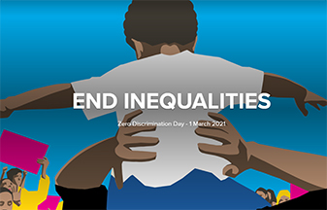**Zero Discrimination Day: Promoting Equality and Inclusion**

Zero Discrimination Day is observed annually on March 1st, highlighting the importance of promoting equality, diversity, and inclusion in all aspects of society. Discrimination, in its various forms, remains a significant barrier to achieving social justice and equality for all individuals, regardless of their race, gender, sexual orientation, disability, or any other characteristic. This day serves as a reminder of the need to eliminate discrimination in all its forms and create a world where everyone is treated with dignity and respect.

**History and Significance**

The origin of Zero Discrimination Day can be traced back to the Joint United Nations Programme on HIV/AIDS (UNAIDS). In 2013, UNAIDS launched the campaign "Zero Discrimination" to combat discrimination against people living with HIV/AIDS. The campaign gained momentum globally, resonating with the broader goal of eliminating discrimination in all spheres of life. Consequently, in 2014, the United Nations General Assembly officially recognized March 1st as Zero Discrimination Day.

The significance of this day lies in its emphasis on the fundamental principle of equality enshrined in the Universal Declaration of Human Rights. It serves as a platform to raise awareness about the detrimental effects of discrimination on individuals and communities and to promote policies and actions that foster inclusivity and diversity.

**Challenges and Progress**

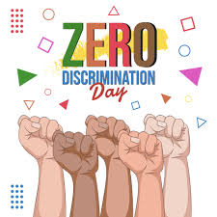Despite significant progress in promoting equality and diversity, discrimination persists in various forms worldwide. Marginalized groups continue to face systemic barriers to accessing education, healthcare, employment, and other basic rights. Discrimination based on race, ethnicity, gender identity, sexual orientation, disability, and other factors undermines social cohesion and perpetuates inequality.

However, efforts to address discrimination have not been in vain. Many countries have enacted laws and policies to combat discrimination and promote inclusion. Civil society organizations and grassroots movements have played a crucial role in advocating for the rights of marginalized communities and challenging discriminatory practices. Moreover, increased awareness and education about the harmful effects of discrimination have contributed to changing attitudes and fostering a culture of acceptance and respect for diversity.

**Promoting Zero Discrimination**

Promoting zero discrimination requires a multifaceted approach that involves governments, civil society, businesses, and individuals. Key strategies include:

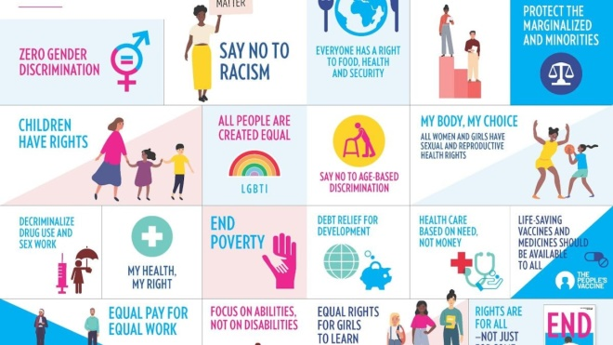1. Legal Frameworks: Governments should enact and enforce laws that prohibit discrimination and promote equality. These laws should cover all forms of discrimination and provide effective remedies for victims.

2. Education and Awareness: Comprehensive education programs are essential to raise awareness about the impact of discrimination and promote understanding and acceptance of diversity. Schools, workplaces, and communities can play a vital role in promoting inclusive attitudes and behaviors.

3. Empowerment: Empowering marginalized groups through access to education, economic opportunities, and political participation is crucial for reducing inequality and promoting social justice.

4. Addressing Root Causes: Addressing the root causes of discrimination, such as poverty, inequality, and social exclusion, is essential for creating a more equitable society.

5. Promoting Diversity and Inclusion: Businesses and organizations should adopt policies and practices that promote diversity and inclusion in the workplace and beyond. Embracing diversity not only fosters innovation and creativity but also contributes to a more inclusive society.

**Conclusion**

Zero Discrimination Day serves as a powerful reminder of the importance of promoting equality, diversity, and inclusion in all aspects of society. By challenging discriminatory attitudes and practices and advocating for the rights of marginalized communities, we can build a world where everyone is treatedwith dignity and respect, regardless of their background or identity. Together, let us strive to create a future where zero discrimination is not just a dream but a reality for all.